**STATUS REPORT: WEEK 9.**

MSIS720 – IS Project (DegreeWorks)

**Vision & Mission Statement:**

"Empowering students with an innovative DegreeWorks platform for clear, efficient academic planning and progression."

**TEAM 4 :**

ADLA MOUNIKA.

CHALLAGALLA SIVA NAGA SOWMYA.

GUDIMILLA NAVEEN KUMAR.

LAKKIREDDY PAVAN KUMAR REDDY.

YASA ABHINAYA.

|  |  |
| --- | --- |
|  | * Created Student GPA, GPA Calculator. |
|  | * Working on Student Subject page. * Building Prototype. |
|  | * NONE |

[Home page - Degree works application (figma.com)](https://www.figma.com/proto/0VVl6W5f2ACr1RO5qWEA2N/Degree-works-application?page-id=0%3A1&type=design&node-id=1-630&viewport=388%2C290%2C0.79&t=IIZy8oNAAejAJr5j-1&scaling=contain)

**PLEASE FIND GPA AND GPA CALCULATOR DESIGNS BELOW**

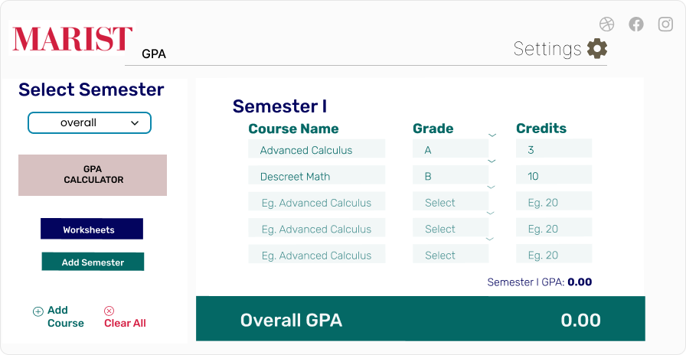

**GPA CALCULATOR**



